Kamal Villejoint

Assignment 4

Part 1: English Typing Test

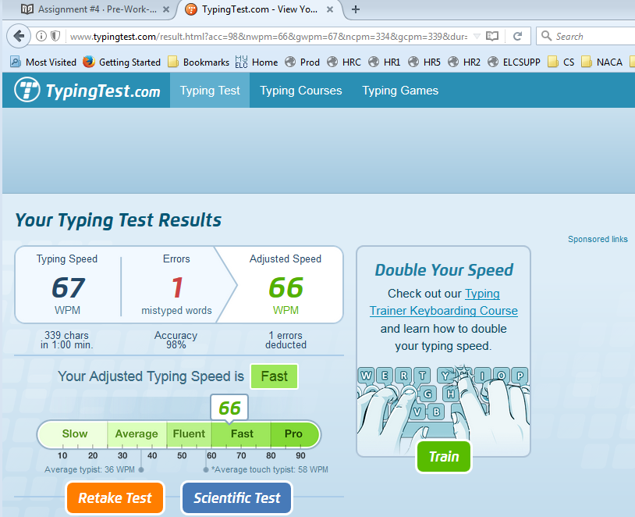

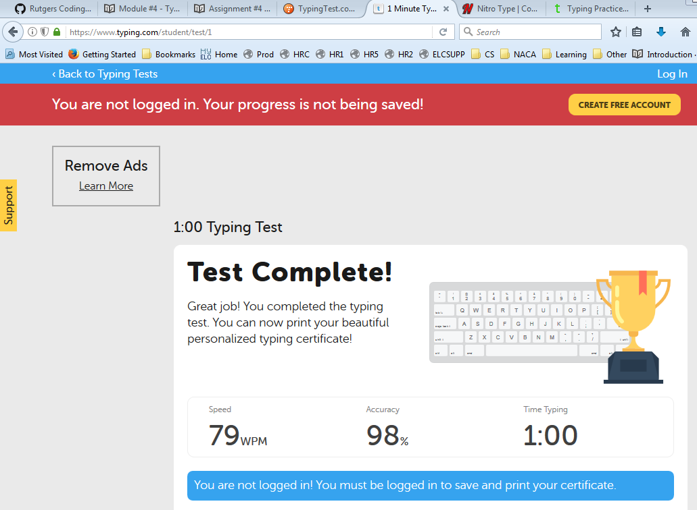

Part 2: JavaScript Typing Test

